Ex.no:6b | DATA VISUALIZATION USING POWER BI

AIM

To visualize and analyze the California Housing Dataset using Line Chart, Bar Chart, and Pie Chart with Power BI to understand housing value trends, ocean-proximity-wise comparisons, and housing distribution patterns.

ALGORITHM

Step 1: Import Pandas and load the California Housing Dataset into the working environment.

Step 2: Load the cleaned California Housing Dataset into Power BI Desktop.

Step 3: Group the housing data according to ocean_proximity and calculate the average median_house_value for each category.

Step 4: Plot the average house value using a Line Chart to observe variations across different ocean proximity categories.

Step 5: Group the dataset according to ocean_proximity and calculate the total number of housing records for each category.

Step 6: Plot the number of houses using a Bar Chart to compare housing records across different ocean proximity categories.

Step 7: Select the ocean_proximity categories and calculate their housing-record proportions.

Step 8: Plot the housing distribution using a Pie Chart.

Step 9: Add suitable titles, axis labels, legends, and display the visualizations.

CODE

# ============================================================

# EX NO: 6B

# DATA VISUALIZATION USING POWER BI

# CALIFORNIA HOUSING DATASET

# ============================================================

import pandas as pd

import matplotlib.pyplot as plt

# Load California Housing Dataset

df = pd.read_csv(

"/content/housing prices.csv",

low_memory=False

)

print("Dataset Loaded Successfully")

# ------------------------------------------------------------

# 1. Line Chart – Average House Value by Ocean Proximity

# ------------------------------------------------------------

house_value = (

df.groupby("ocean_proximity")["median_house_value"]

.mean()

)

plt.figure(figsize=(10, 5))

plt.plot(

house_value.index,

house_value.values,

marker="o"

)

plt.title("Average House Value by Ocean Proximity")

plt.xlabel("Ocean Proximity")

plt.ylabel("Average Median House Value")

plt.xticks(rotation=45)

plt.grid(True)

plt.tight_layout()

plt.show()

# ------------------------------------------------------------

# 2. Bar Chart – Number of Houses by Ocean Proximity

# ------------------------------------------------------------

house_count = (

df.groupby("ocean_proximity")

.size()

.sort_values(ascending=False)

)

plt.figure(figsize=(12, 6))

plt.bar(

house_count.index,

house_count.values

)

plt.title("Number of Houses by Ocean Proximity")

plt.xlabel("Ocean Proximity")

plt.ylabel("Total Number of Houses")

plt.xticks(

rotation=45,

ha="right"

)

plt.tight_layout()

plt.show()

# ------------------------------------------------------------

# 3. Pie Chart – Housing Distribution

# ------------------------------------------------------------

housing_distribution = (

df["ocean_proximity"]

.value_counts()

)

plt.figure(figsize=(8, 8))

plt.pie(

housing_distribution.values,

labels=housing_distribution.index,

autopct="%1.1f%%"

)

plt.title("Housing Distribution by Ocean Proximity")

plt.show()
print("\nEXPERIMENT 6B COMPLETED SUCCESSFULLY")

OUTPUT

LINE CHART
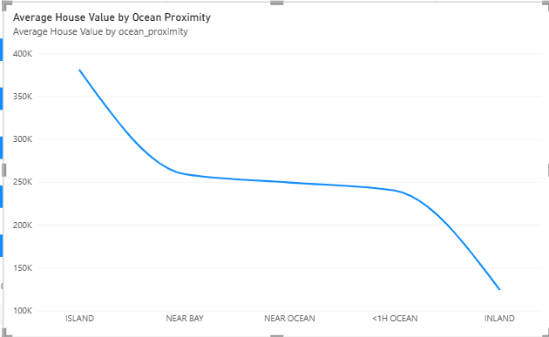

BAR CHART

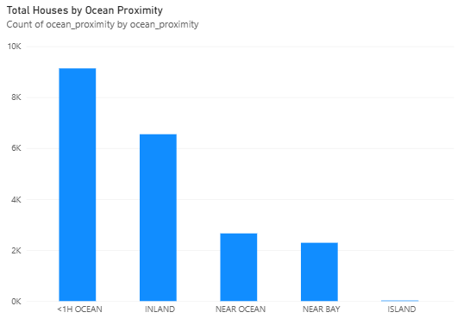

PIE CHART
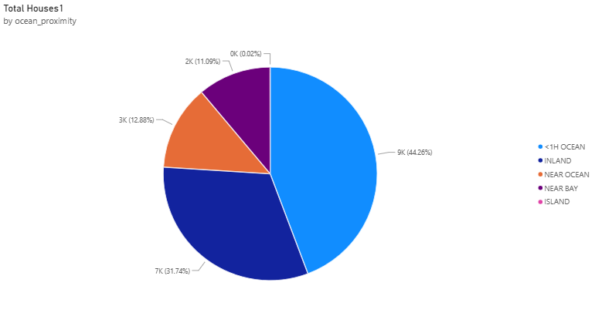

RESULT

